Title of my Abstract for Modval19, 21-23 March 2023
A. Author¹*, C.O. Writer¹, H. Experiment², V.A. Lidate³, M.Y. Boss¹
¹University, (Faculty/Department), (Institute), (Laboratory), ZIPcode-Town, Country
²Company XYZ, company adress, ZIPcode-Town, Country
³Research Center ABC, (Division), (Institute), (Laboratory), ZIPcode-Town, Country
*(corresponding author email address:) name.author@institute.com

The abstract is set up on ONE A4 PAGE with mirror margins: top 2.5 cm, bottom 2.5 cm, inside 3.5 cm, and outside 2.5 cm. The main text is formatted in 10 pt Arial font, justified, single-spaced, with a 1.27 cm first line indent.
Ut varius urna velit, a iaculis leo pellentesque a. Fusce id faucibus mauris, in pulvinar sapien. Morbi tortor elit, efficitur tempus consequat id, rhoncus sit amet turpis. Maecenas eget libero mi. Suspendisse sem urna, laoreet nec nulla non, convallis porttitor velit. Suspendisse eu tincidunt quam. Nullam vulputate elit sapien, eget finibus urna tempor eget. Cras imperdiet ipsum blandit aliquam suscipit. Curabitur rhoncus lobortis est nec laoreet. Donec volutpat neque leo, sed ultrices erat tristique vel. Praesent sit amet ultrices sem, sed molestie neque. Vestibulum ante ipsum primis in faucibus orci luctus et ultrices posuere cubilia curae; Curabitur in ligula justo. Quisque nec suscipit metus, ornare placerat ex.

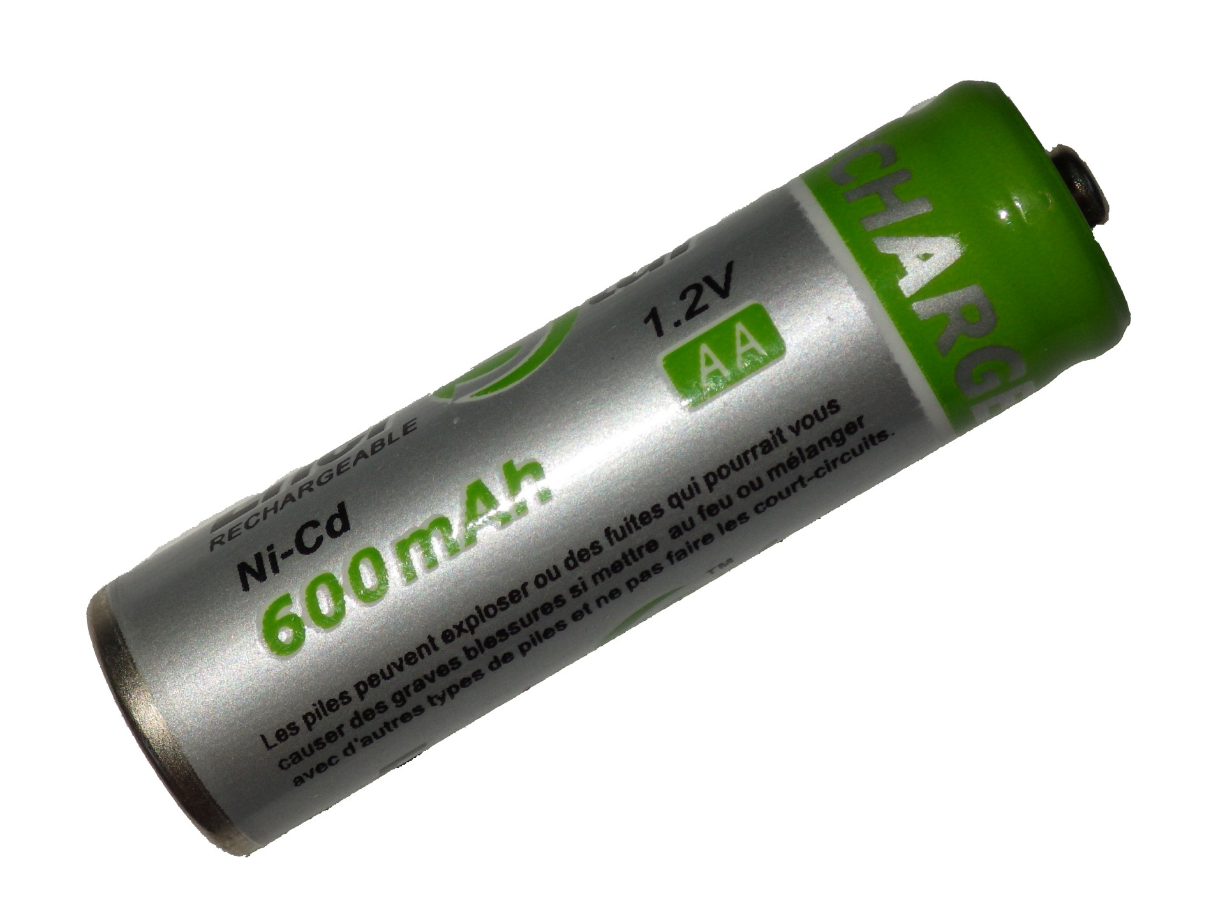  Figure 1: battery | 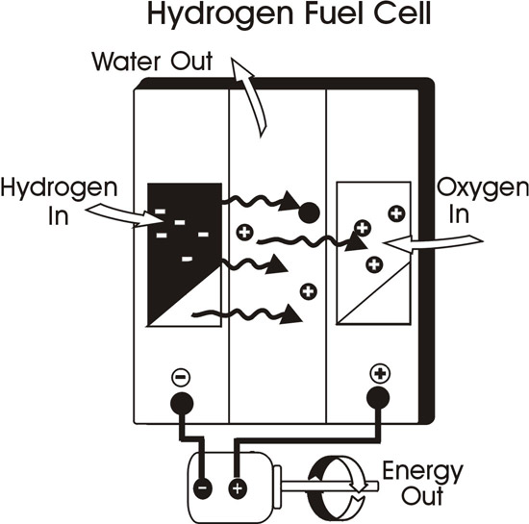 Figure 2: fuel cell

- Author, A.; Writer, C.O. et al. Journal 2021, 83 (5), 2345-2356. DOI: 12.3456/abcd.xyz
- References in ACS style

